Transfermations can be applied to any of the layers in neuroglancer by entering the parameters to the source tab of a given layer.

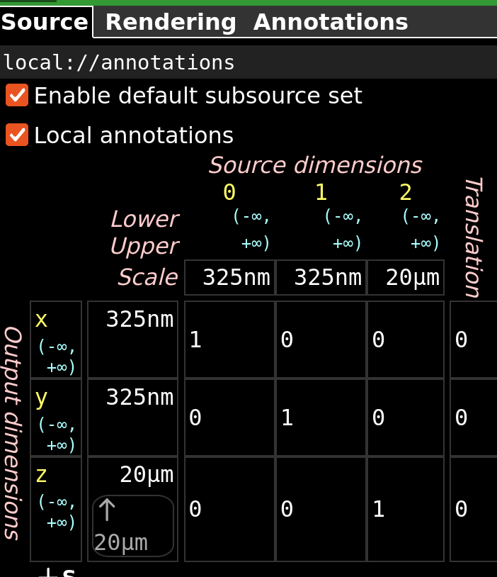

A set of parameters for commonly used transformations can be retrieved and automatically applied to the current layer from the database by the custom transformation drop down.

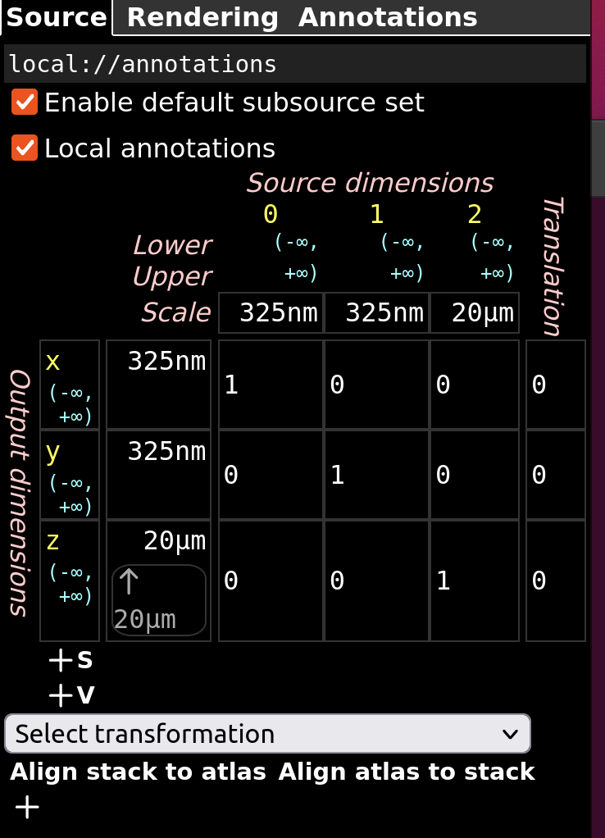

**Applying Transformation**

1. When Applying transformations to images from a specific brain DKXX, including volumes and annotations made for that brain, select an item containing DKXX from the drop down and click “Align stack to atlas”. This will align the current layer to the Active atlas.
2. When Applying transformation to Atlas Volumes, select the brain you are transforming to and click “Align atlas to stack”

**Choosing a Transformation**

There might be more than one option for a given brain:

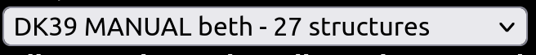

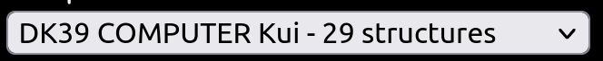

As transformations are calculated by finding the parameters that best align from one set of COM to another ( usually from brain COM to atlas COM), multiple transformations can be calculated depending on the set of brain COM used.

The Drop down shows all available COMs that can be used to calculate the transformation and shows the information about each group of available COMs in the following format:

DKXX SOURCE_OF_ANNOTATION ANNOTATOR - number_of_structures_annotate

So DK39 MANUAL beth - 27 structures will calculate the transformation by using manually COM annotations by Beth on the Brain DK39